Chapter 13, Problem 9.

Find V_{x} in the network shown in Fig. 13.78.

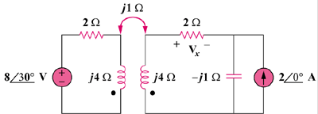

Figure 13.78
For Prob. 13.9.

